Part E
Statement of Compliance

RFT AM-11252
Printing of SLP Teaching and Learning Materials
Printing of Grade 1 Lao Language Teacher Guide (Book 1)
Printing of the Primary Curriculum Framework

Production of the materials shall comply with the following Technical Specifications and Standards.

Instructions:

- Next to each item, bidders are to write “Comply” or “Not Comply” and add any comment as required.
- Where information is presented in the specification, bidders should insert the comment “Noted”.
- The technical specification in this Statement of Compliance shall not be altered in any way, either by email or by scanning the completed document for submission.
- Any variation to this Statement of Compliance should be stated and fully explained in the Statement of Compliance column without making any changes to the technical specification details.
- Any changes to the Statement of Compliance may invalidate the Bid.
- Each page shall be duly authorised, signed, dated and stamped using the bidder's company stamp.

Date: ………………………………. Authorised Signature: ……………..…………………… Company Stamp:

Item No | SPECIFICATION DETAIL # | STATEMENT of COMPLIANCE  “Comply” or “Not comply”
1 | Specific Experience:  Bidders are to offer products matching the specification below and provide details of the offer.  The Bidder shall provide documentary evidence to demonstrate that it meets the following specific requirements.  - The teaching and learning materials referred to in the following specifications are under copyright held by Lao PDR Ministry of Education and Sports.  - The Bidder will be responsible to follow the specifications and to ensure that there is no variation from the requirements.  - The Bidder shall demonstrate that their company has documented and effective internal quality control procedures for the production of large volumes of textbooks, teacher guides, posters, flash cards and similar products.
2 | Summary of Requirements:  There is a requirement for a quantity of textbooks, teacher guides and game cards to be printed, for use by the Lao PDR Ministry of Education and Sports, as below.  These teaching materials will be used in schools where conditions will affect their lifespan. It is important that only the materials specified are used to ensure the books and cards last a long time in the classroom.
3 | Due Dates:  The delivery date for Batch 1 materials is Friday 28th June 2024.  The delivery date for Batch 2 materials is Friday 5th July 2024.  The delivery period for Batch 3 materials starts on Monday 8th July 2024, must be completed by Friday 10th August 2024 and must meet the delivery schedule and requirements of the warehouse manager.
4 | Production Schedule  The following items should be included in the written production schedule included in Part D:  - sourcing printing and packaging material (paper, card, etc.)  - delivery date of digital press proofs  - delivery date of fully bound press proofs  - printing, cutting, collating, shrink-wrapping  - delivery date of sample cartons  - packing and labelling and  - delivery of all batches to a central warehouse in Vientiane, Lao PDR.  The Bidder is required to submit their own production and delivery schedule which will be part of the assessment criteria at the evaluation of bids.
5 | Production Quantities  Bidders will provide prices based on the following items and quantities below:  Item Inside Pages Cover Size Quantity  Grade 1 Spoken Lao Program Textbook 152 4 18 x 25 cm 184,680  Grade 1 Spoken Lao Program Teacher Guide 280 4 A4: 21 x 29.7 cm 13,680  Grade 1 Lao Language Book 1 Teacher Guide 222 2 A4: 21 x 29.7 cm 15,792  Primary Curriculum Framework 156 2 A4: 21 x 29.7 cm 12,336  Grade 1 Spoken Lao Program Card Set: # Cards  Unit 5 Bingo Cards: 6 per set 6 A5: 14.8 x 21cm 40,880  Unit 10 Bingo Cards: 6 per set 6 A5: 14.8 x 21cm 40,880  Unit 16 Story Cards: 12 per set 12 A5: 14.8 x 21cm 13,680  Unit 29 Story Cards: 6 per set 6 A5: 14.8 x 21cm 13,680  Picture and Word Cards: 111 per set 111 A5: 14.8 x 21cm 13,680  Other  Instruction Sheet: 1 per box 2 pages A4: 21 x 29.7 cm 13,680  Lid and Tray Box: To fit all cards and instruction sheet folded to A5. 13,680  Please refer to additional information in Part F Price Schedules.
3 | Dummy Samples: Textbooks  3 Blank dummy samples to be submitted with the bid.  Additional printed samples from any similar book print runs can also be submitted with the bid.  (3 sample books are sufficient).  Dummy Samples: Teacher Guides  3 Blank dummy samples to be submitted with the bid.  Additional printed samples from any similar book print runs can also be submitted with the bid.  (3 sample books are sufficient).  Dummy Samples: Game Cards  1 blank dummy sample.  Dummy Samples: Instruction Sheet  1 blank dummy sample.  Dummy Samples: Lid and Tray Box  1 blank dummy sample.  The Bidder must inform Tetra Tech of any perceived errors in the specifications.
4 | Inside text pages 80gsm: All Books  The paper for the inside pages is to be made from good quality, wood-free, 80gsm offset paper with brightness to be 80% to 85% with opacity of no less than 85% +/- 5%.
5 | Cover Stock 230gsm: All Books  The cover is to be made from one-sided Art board of no less than 230gsm weight with the grain direction running parallel to the spine.  The front and back cover are all printed 4 colour process and finished with gloss lamination on the outside.
6 | Card Stock 300gsm  All card stock is to be good quality, white 300gsm artboard.  All bingo cards are printed 4 colours on 1 side and finished with matte lamination on both sides.  All story cards are printed 4 colours on 1 side and finished with matte lamination on both sides.  All picture and word cards are printed 4 colours on 1 side and black text on 1 side and finished with matte lamination on both sides.
7 | Instruction Sheet, 160gsm  A4, 210 x 297 mm, printed full colour on 160gsm gloss artboard, matt laminated, folded to A5 and packaged inside the lid and tray box.
8 | Lid and Tray Card Boxes, 3 ply  Corrugated 3 ply Natural (Brown) Kraft Paperboard lid and tray boxes, printed black text on the lid and gloss varnished to fit 1 complete set of game cards and instruction sheet.
9 | Printing Ink:  The printing ink, 4 colours (CMYK), is to be of good quality and suitable for use on the above specified paper and card types. The inks shall not unduly fade or smudge under conditions of normal physical use.
10 | Binding Style:  PUR for all Textbooks  Covers to be firmly attached at the spine using a PUR quality adhesive. The cover hinge crease shall be no less than six (6) mm from the spine both front and back. The spine adhesive must not extend beyond the hinge crease.  Section Sewn for all Teacher Guides and Primary Curriculum Framework  Covers to be firmly attached at the spine using a good quality adhesive. The cover hinge crease shall be no less than six (6) mm from the spine both front and back. The spine adhesive must not extend beyond the hinge crease.
11 | Pre-press Production Data:  Font styles and point sizes are to be maintained exactly as per the electronic PDF files held by the Lao PDR Ministry of Education and Sports. All illustrations, tables and pictures, the language and purpose for which the books, posters and cards are to be used, must be as per the approved proofs supplied.  Print Quality High Resolution PDF files will be provided based on printer specifications.
12 | Pre-Press Digital Proofs:  1 full colour digital press proof of each book complete with cover.  1 digital proof of each card.  1 digital proof of the card box.  Each Proof will be submitted to Tetra Tech BEQUAL for approval.  Written approval from Tetra Tech BEQUAL must be received before proceeding to hard copy press proofs.
13 | Full Colour, Fully Bound Press Proofs:  3 full colour, fully bound sample press proofs of each book.  3 hard copy proofs of each card set and card box.  Press proofs are to be produced complete with all pages and covers, all cards with boxes, and submitted to Tetra Tech BEQUAL for approval.  Written approval from Tetra Tech BEQUAL must be received before any production commences.  The Lao PDR Ministry of Education and Sports will sign and stamp all copies returning one copy to the supplier.  Quality assurance will be carried out by Ministry of Education and Tetra Tech BEQUAL representatives during production to confirm conformity with the specifications and the signed copies. Remote monitoring will require the supplier to provide photographic and video records via email to Tetra Tech BEQUAL on a fortnightly basis or as requested during production processes.
14 | Fully Packed Samples:  - 1 fully packed carton of grade 1 SLP textbooks  - 1 fully packed carton of grade 1 SLP teacher guides  - 1 fully packed carton of grade 1 Lao Language teacher guides  - 1 complete set of the grade 1 cards and instruction sheet packed in the lid and tray box  must be received by Tetra Tech BEQUAL staff in Vientiane for checking and approval before cartons are shipped.
15 | Packing and Protection:  All items must be packed and protected against damage during delivery and storage. Any special storage precautions required to protect the books should be clearly notified on each and all of the consignments.
16 | Grade 1 SLP Textbooks  The textbooks are to be packed in sets of 6 books and shrink-wrapped.  4 sets per regular carton.  24 books in total per carton.  1 set of 6 textbooks 4 sets of textbooks per carton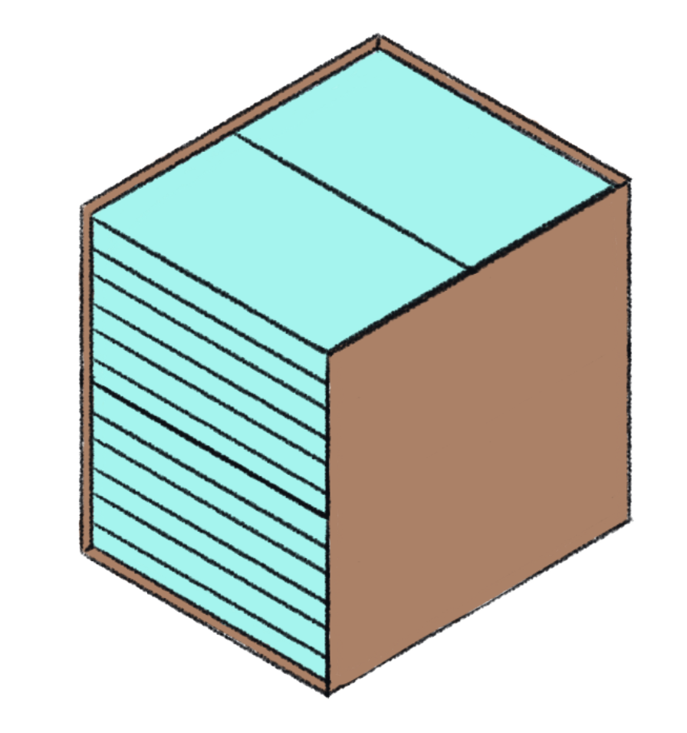  - Cartons should be clearly labelled to a maximum size and printed or glued on the short and long side of the cartons.  - Each label must contain – Grade, Book Title, Contract Number, Weight, Number of sets and books in each carton in Lao language.  - Labels will be produced in 4 colours – pink, blue, yellow and white indicating the recipient of the carton. A PDF of each label will be provided to the supplier when required.  - The carton size will be determined by the supplier. Each regular carton will contain 4 sets of 6 books = 24 books.  Total Grade 1 SLP textbook cartons: 184,680 books at 24 books per carton = 7,695 cartons
17 | Grade 1 SLP Teacher Guides  The Teacher Guides are packed in sets of 6 books and shrink-wrapped.  4 sets per regular carton. 24 books in total per carton.  1 set of 6 teacher guides 4 sets of teacher guides per carton  - Cartons should be clearly labelled to a maximum size and printed or glued on the short and long side of the cartons.  - Each label must contain – Grade, Book Title, Contract Number, Weight and Number of sets and books in each carton in Lao language.  - Labels will be produced in 3 colours – blue, yellow and white indicating the recipient of the carton. A PDF of each label will be provided to the supplier when required.  - The carton size will be determined by the supplier. Each regular carton will contain 4 sets of 6 teacher guides = 24 books.  Total Grade 1 SLP TG cartons: 13,680 books at 24 books per carton = 570 cartons
18 | Grade 1 Lao Language Book 1 Teacher Guides  The teacher guides are packed in sets of 6 and each set is shrink-wrapped.  4 sets per regular carton. 24 books in total per carton.  1 set of 6 LL teacher guides 4 sets per carton 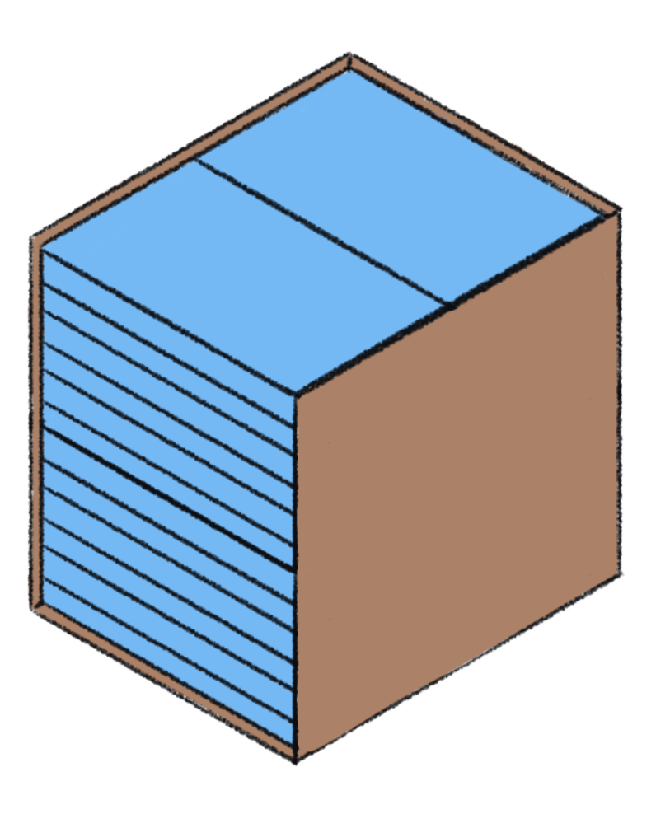  - Cartons should be clearly labelled to a maximum size and printed or glued on the short and long side of the cartons.  - Each label must contain – Grade, Book Title, Contract Number, Weight and Number of sets and books in each carton in Lao language.  - Labels will be divided into 3 colours – blue, yellow and white indicating the recipient of the carton. A PDF will be provided to the supplier when required.  - The carton size will be determined by the supplier. Each regular carton will contain 4 sets of 6 teacher guides = 24 books.  Total Grade 1 Lao Language TG cartons: 15,792 books at 24 books per carton = 658 cartons
19 | Primary Curriculum Framework  The primary curriculum framework books are packed in sets of 6 and each set is shrink-wrapped.  4 sets per regular carton. 24 books in total per carton.  1 set of 6 books 4 sets of books per carton. 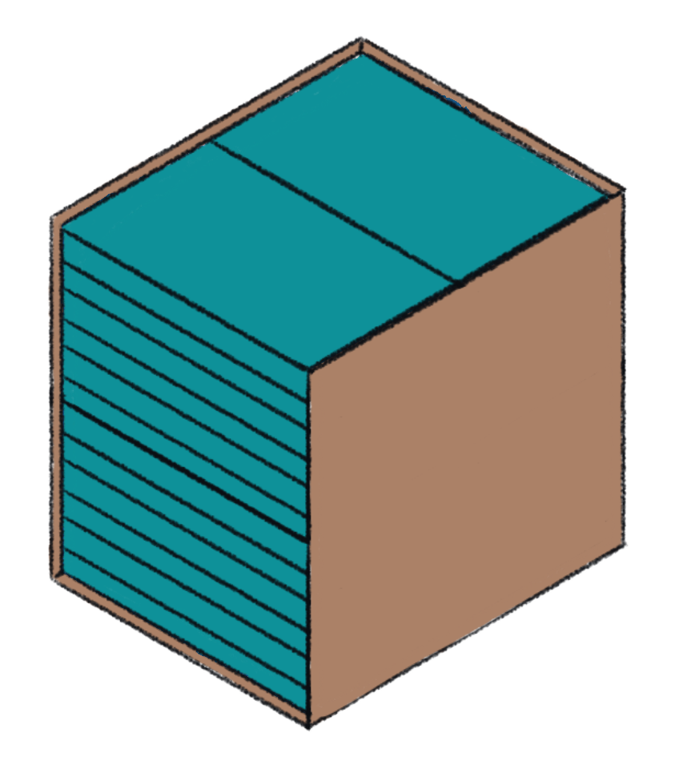  - Cartons should be clearly labelled to a maximum size and printed or glued on the short and long side of the cartons.  - Each label must contain – Grade, Book Title, Contract Number, Weight and Number of sets and books in each carton in Lao language.  - Labels will be divided into 3 colours – blue, yellow and white indicating the recipient of the carton. A PDF will be provided to the supplier when required.  - The carton size will be determined by the supplier. Each regular carton will contain 4 sets of 6 teacher guides = 24 books.  Total Primary Curriculum Framework cartons: 12,336 books at 24 books per carton = 514 cartons
20 | Card Sets (13,680)  The card sets will be packed in a lid and tray box containing:  - 1 pack Unit 5 Bingo cards (6 cards)  - 1 pack Unit 10 Bingo cards (6 cards)  - 1 pack Unit 16 Story cards (12 cards)  - 1 pack Unit 29 Story cards (6 cards)  - 1 pack of picture and word cards (111 cards)  - 1 instruction sheet  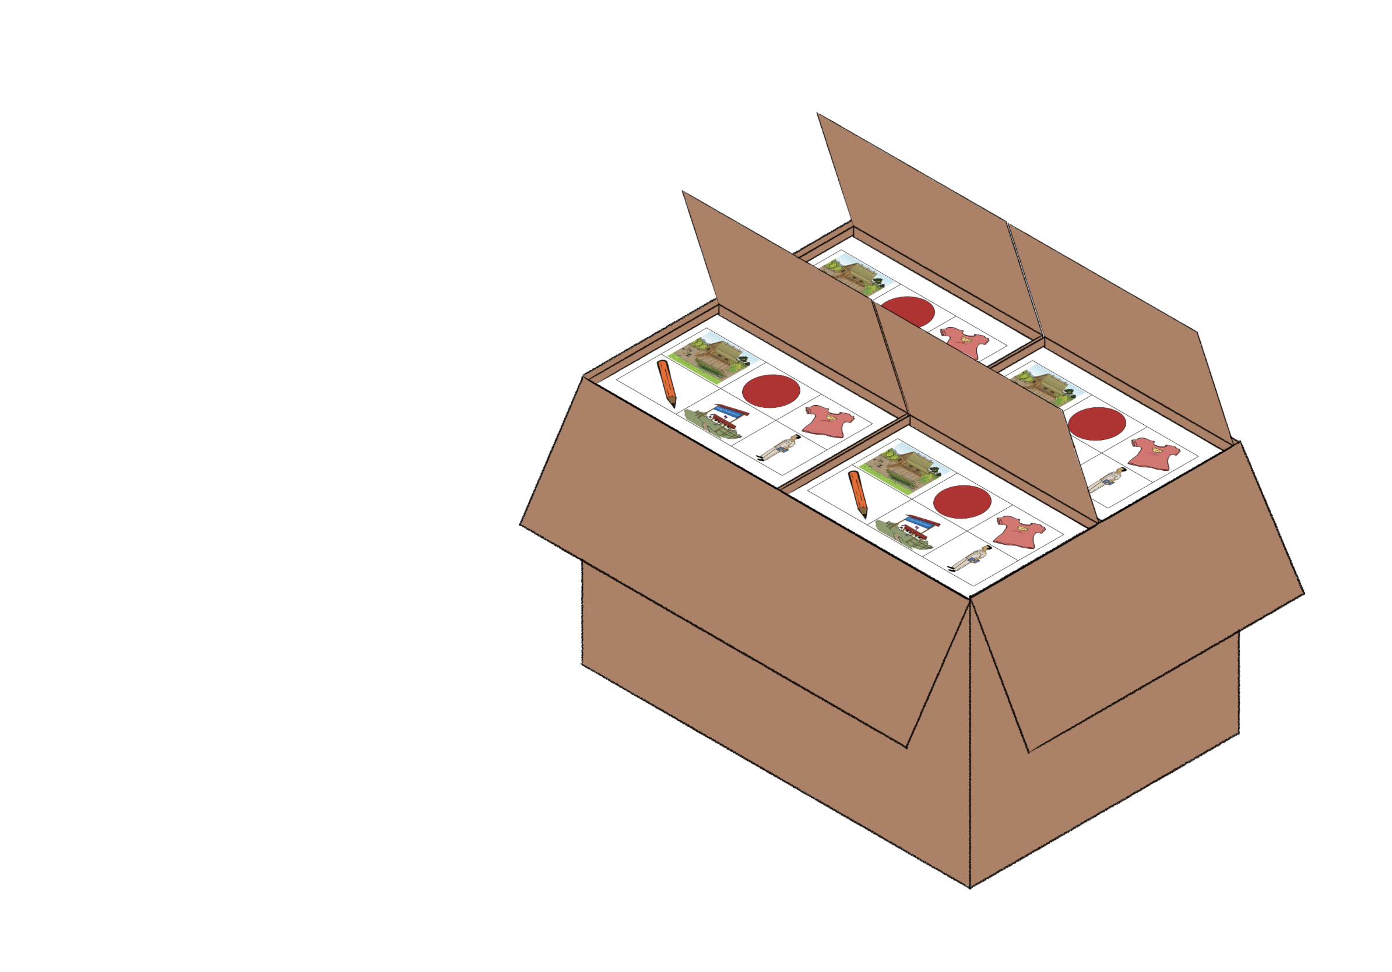  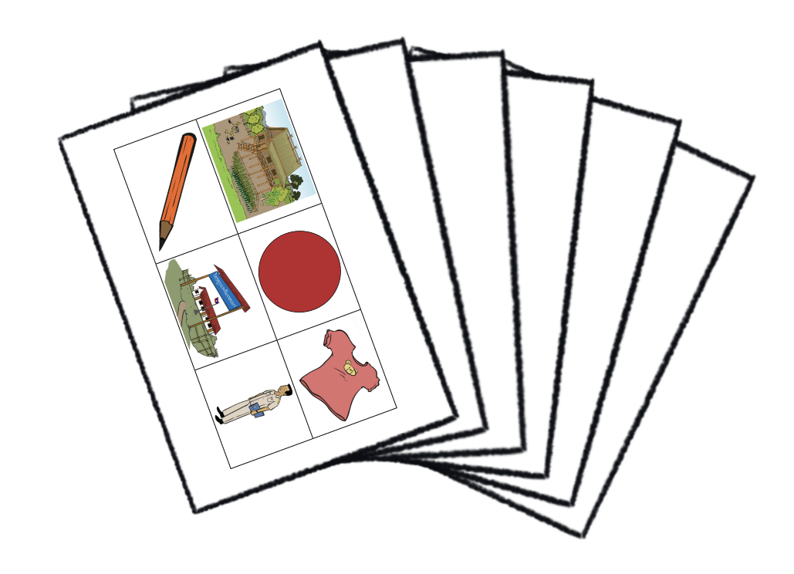  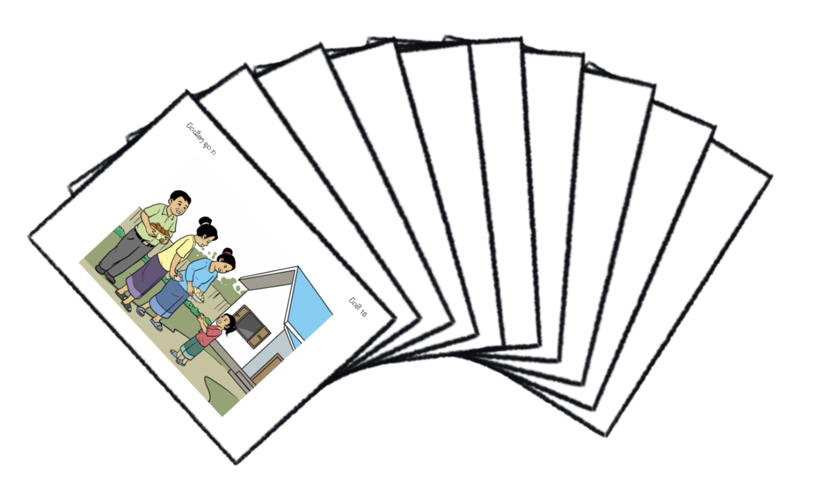  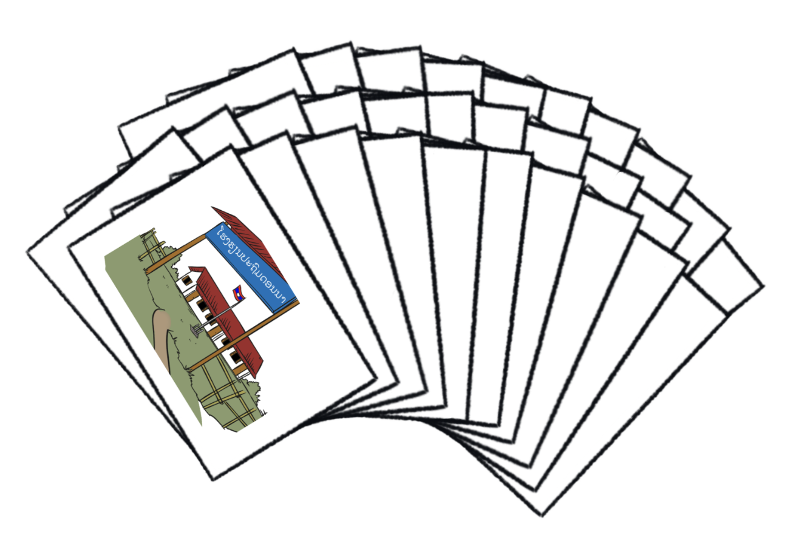  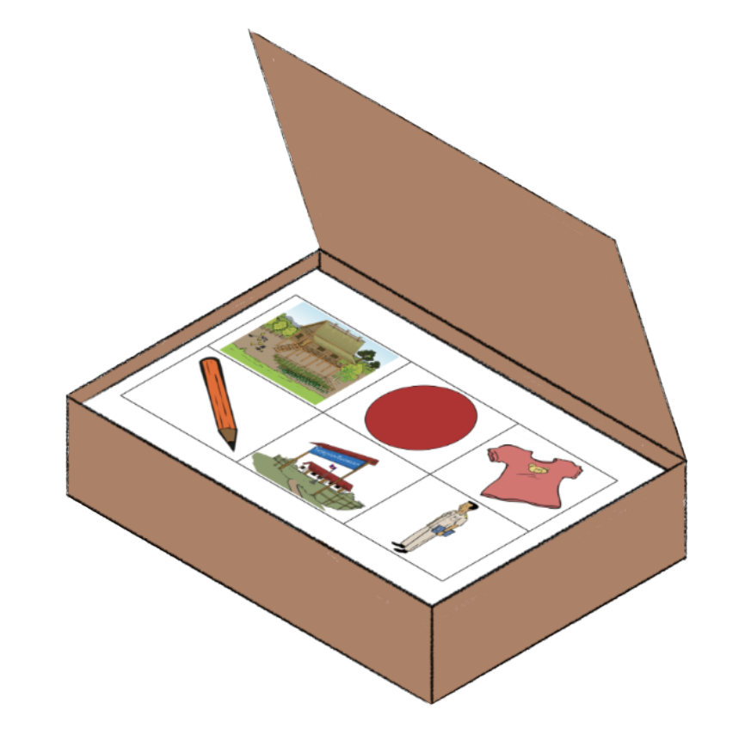  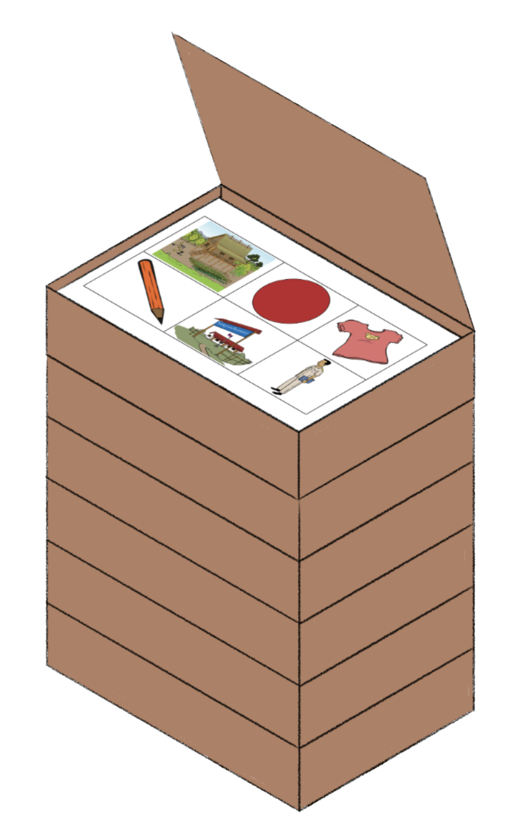  The Lid and Tray box will be made from corrugated 3 ply Natural (Brown) Kraft Paperboard, printed black text on the lid and gloss varnished to fit 1 complete set of game cards and instruction sheet. The supplier will determine the correct size to fit the contents.  1 pack of bingo cards 1 set of story cards 1 set of picture cards  1 box of all cards 6 boxes strapped together into a bundle 4 bundles per regular carton  - Regular Cartons should be clearly labelled to a maximum size and printed or glued on the short and long side of the cartons.  - Each label must contain – Grade, Item Name, Contract Number, Weight and Number of Items in each carton in Lao language.  - Labels will be divided into 3 colours – blue, yellow and white indicating the recipient of the carton. A PDF will be provided to the supplier when required.  - The carton size will be determined by the supplier. Each regular carton will contain 4 sets of 6 card bundles = 24 card boxes.  Total cartons: 13,680 card sets at 24 per carton = 570 cartons
21 | Extra Unit 5 and Unit 10 Bingo Cards  27,200 Extra sets of Unit 5 and 27,200 Unit 10 Bingo Cards to be produced.  1 set of Unit 5 cards and 1 set of Unit 10 cards will be shrink wrapped as a pack of 12 cards. 100 packs of cards per regular carton.  - Cartons should be clearly labelled to a maximum size and printed or glued on the short and long side of the cartons for ease of visibility.  - Each label must contain – Grade, Item Name, Contract Number, Weight and Number of Items in each carton in Lao language.  - Labels will be divided into 3 colours – blue, yellow and white indicating the recipient of the carton. A PDF will be provided to the supplier when required.  - The carton size will be determined by the supplier. Each regular carton will contain 100 packs of Bingo Cards.  Total cartons: 100 card packs per carton = 272 cartons
22 | All Delivery Cartons  The Delivery Carton cardboard must not be less than 5 ply export quality.  Material: Kraft liner board  Corrugation: B, C or E (double wall) flute  Burst strength: 1 4.09 kgs/cm2 or 200.4 psi or 1409 kPa all with + 2% tolerance  Each carton to be plastic strapped twice crosswise, using heat sealing that will create a flat surface and not damage the books or cards.
23 | Packing on Pallets:  For all suppliers, the cartons must be on pallets of a size that will enable them to be loaded onto side opening box trucks for ease of customs inspection and clearance at the Lao border.  All pallets to be clear plastic film wrapped (using film no less than 19 microns) then strapped with a sturdy wood board on the top to enable pallets to be stacked on top of one another at destination. Pallet height not to exceed 1.7 metres.  Pallets to be labelled with an A3 label under the last layer of plastic film. Each label must contain - Purchase order number, book titles, grade, weight and number of books on a carton in Lao and English languages.
24 | Delivery:  Each item is to be produced in its entirety as a 100% print-run, collated and shrink-wrapped, and packed as detailed above.  Delivery to a central warehouse in Vientiane, Lao PDR - Delivery to the door.  International Supplier/s will be required to facilitate door to door delivery including customs clearance and importation of the items.
25 | Inspection/Monitoring:  An onsite product inspection will be undertaken during the printing production by Tetra Tech and representatives from the Ministry of Education and Sports. The supplier will advise the suitable time during production when printing, collating, cutting and binding can be inspected.  The supplier is required to provide regular photographs and videos during the production process that demonstrate progress.  Pre-delivery remote inspection of the packing of cartons will take place prior to the FIRST shipment of each item by Tetra Tech at least 3 days before the shipment is made. One packed carton of each of the textbooks, the teacher guides, the flash cards will be sent to Vientiane BEQUAL staff via trackable courier for inspection and approval of packing and labelling.
26 | Subcontracting:  Bidders MUST identify on their bid, all products or services used during the production of the items, that originate from another supplier and/or country.  All book production subcontracting must be declared and reviewed by Tetra Tech prior to contract award.
27 | Penalty Clause:  In the event the supplier/s fail to deliver the ordered supplies within the stipulated time, Tetra Tech reserves the right to apply penalties for late deliveries at the rate of 0.5% on a daily basis to a maximum value of 20% of the contract value.

